# Unit 7 Assignment – Final Project: Marketing Plan

# Amon-ra

# Herzing University

# BU 615-7 Marketing and New Product Development

# MARKETING PLAN

# Computer Doctor

### Amon-ra, Owner

### October 20, 2019

1. **COMPANY NAME**

Computer Doctor

1. **EXECUTIVE SUMMARY**

Computer Doctor is a new business venture dedicated to building long-term relationships with customers by providing unprecedented, thorough, professional, and precision care for computers and networks. The company is the brainchild of Amon-ra. Mr. Amon-ra worked as a network engineer for a large corporation. He regular encounters users of computers, some of which are business owners. He would often be asked what type of work he performed. Upon hearing that he worked in a computer-related field, he was often solicited for technical assistance with wide-range of computer issues.

With computer service businesses available in the vicinity, why does there seen to be an unmet demand? Customers are not satisfied with the service that is presently being provided by the status quo businesses. Thus, Computer Doctor was born. Our business has identified a need in the quality of service that is presently available to the target market, therefor the business will provide a level of care that goes beyond present standards an exceeds customer expectations. We aim to position the company as a leader in computer and network repair by creating, setting, and being the highest standard.

As the name suggests, Computer Doctor treats every computer and network as a patient. Our motto, “Never Lost a Patient” attests to the level of care that we provide in diagnosing, treating, and preventing computer issues.

1. **SITUATION ANALYSIS**

Present market conditions reveal the target market increasingly utilizes computer technology and as usage increases so does the number of technical opportunities. Smart scales, smart watches, smart locks, smart lights, smart homes, smart phones, smart refrigerators, smart washer and dryers, smart over, smart cameras, computer-based technical is spreading and being utilized more throughout society and this in additional to desktop computer, laptops, tablets and the network that connects them to one another. Figure1

This technological phenomenon creates a never-ending list of business opportunities, which is one business challenge. Though the opportunities are wide, business services cannot be. No business can satisfy all customer needs and just decide on a section of the marker to cater to and fulfil those needs. The most common of that technology is network. Every household relies on internet as well as all its computerized devices, which connects for communication purposes. More households have a smart phone than a “personal computer” in the form a laptop or desktop, yet for productivity purposes a smart phone is very impractical due the to the viewing area. “Yes, smartphones and tablets are indeed considered computers. A computer is really any device that accepts input from a user, performs calculations on that input, and provides an output to the user.” (“Are smartphones and tablets computers”, 2018) For the aforementioned reasons we decided to forgo the mobile market segment and focus on the desktop and laptop segment of the computer repair market.

Competition is varied and their approach to the market is equally varied, yet due to limitless amount to technology available to the market, we see no scarcity in operating space.

1. **CUSTOMER**

Customer are classified into two categories:

* 1. Residential
     1. A residential customer is an individual seeking service for a device that is personally owned.
  2. Commercial
     1. A commercial customer can be an individual, group of individuals, or business entity seeking service for a device that is the property of said business.

For customers visiting our location, are welcome and their physical address is not a factor and need not be considered. Onsite repair requires focusing on a particular demographic. Computer Doctor onsite service area will consist of those customers located in within Atlanta Georgia, Fulton county area.

* 1. Residential target market consists of home-based computer users that act strictly as end-users with no means of resolving computer problems when they arise. Most residential customers are not tech-savvy and use their computers for entertainment purposes or as productivity tools, e.g. Web browsing and using email services. For this segment of the target market, a computer is an essential household item.
  2. Commercial target market comprises smaller businesses, professionals or operations that lack the technical know-how and staffing to support their computers. A few examples would be the local coffee shop, medical doctors, dentists, lawyers, and optometrists with private practices, eateries, dry cleaners, i.e. local businesses. Such businesses do not have the budget to hire fulltime information technology staff. Regardless of the size of the company, for commercial sector, downtime needs to be to a minimum. When computers and networks are not working, the business is not functioning and this translates as a loss of revenue for the business.

1. **COMPETITION**

Our competitors consist of big national chains such as Best Buy's Geek Squad, Office Max, Office Depot, brand warranty technical support, and small local repair businesses.

Listing of Small Local Competitors

AVS Computer Services

235 Peachtree Street NE, Suite 400

Atlanta, GA 30303

<https://avscomputer.com/>

Euclid Networks  
113 Pearl Street SE

Atlanta, GA 30316

http://www.euclidnet.com/

GIM Computers.com

1503 Northside Dr NW

Atlanta, GA 30318

Tech Atlanta Computer Repair

73 Peachtree St. SW  
Atlanta, GA. 30303

http://techatlantacomputerrepair.com/

Tech,Genius  
590 Ponce De Leon  
Atlanta, GA 30308

<http://www.techgenius.io/>

Nano Second Computers

1170 Peachtree St, Suite 1200

Atlanta, GA 30309

http://nanosecondcomputers.com/

Onyx Consulting, Inc.

1634 Northside Dr NW

Atlanta, GA 30318

http://onyxconsulting.com/

1. **STRENGTH, WEAKNESSES, OPPORTUNITIES AND THREATS (SWOT)**
   1. **STRENGTH**
      1. We deliver the highest quality service by ensuring that all our technicians are industry certified and that those certification credentials are current.
      2. Onsite repair for residential and commercial customers.
         1. Residential onsite repair offers a convenience for customers that may not have the opportunity to visitor our location. Instead of the customer having to find the time to find Computer Doctor into their busy schedule, one of our technicians will arrive onsite to provide service. This is a extreme benefit to many customers and enables them to multitask by getting more tasks completed. While a computer Doctor technician is servicing their pc or network, the customer can attend to other household tasks.
      3. Commercial onsite repair ensures businesses that when they encounter an issue with the computer systems and network, Computer Doctor will dispatch to the site to get the business up and running so that it can resume generating revenue.
   2. **WEAKNESSES**
      1. We do not service Mac or Apple products. Nor do we service tablets or phones. “Forrester Research’s largest annual survey of Americans technology adoption finds that 73 percent of the 37,000 respondents claim the mobile phone is the electronic device they use the most.” (Tsirulnik, 2019) We are a Microsoft Windows, PC, and PC compatible business with no plans of servicing Mac and Apple products. However, the mobile device market is an area of the market that we considering for future expansion. That expansion should increase our revenue. It is worth exploring if phone and tablet repair should be among the initial support services, yet perform by a 3rd party and later brought inhouse.
   3. **OPPORTUNITIES**
      1. Our target market finds it difficult to obtain reliable technicians that actually troubleshoot to uncover the actual cause of various computer problems. Thus, the root of the problem is never specifically addressed and no explanation as to the origin of its occurrence is given. A "start from scratch" cure all approach is often the method taken, whereby all computer content is erased and reinstalled. As a result, our target market is subjected to a loss of data, applications, configuration settings, unnecessary downtime, etc.
   4. **THREATS**
      1. Some competitors service both Microsoft Windows computers and Mac. This translates as being able to serve both computer market segments. Additionally, tablet and phone repair service is offered by many some of our competitors. This presents an opportunity for our competition to generate a sale and potentially the customer could explore other service options that we may have provided past.
2. **MACRO ENVIRONMENT ANALYSIS**

In reviewing the macro economic environment, its trends and how its forces will affect the environment of the business, we have formed the following conclusions:

* 1. **SOCIO-CULTURAL FORCES**
     1. Social trends can greatly influence attitudes toward products and services. In this age where there are stories of devices being hacked for privacy intrusion purposes and the public’s personal data being at risk due to security breaches, this may have heightened customer’s sensibilities to computer usage though it being a vital tool in today’s world. To combat with this, we should assure our customers that we always have a proactive plan of action to take all the necessary steps, explain those steps, and even make recommendations of any action that can be taken on their part.
  2. **ECONOMIC FORCES**
     1. Economic forces can limit the spending power of our target market, yet with the computer performing a vital function in society, the industry is sure to have some cushion from recessions. The biggest concern would be sanctions or tariffs on countries that are manufactures of computer components. We would all experience some discomfort from such action.
  3. **COMPETITIVE FORCES**
     1. Do our competitors offer better service, better quality, better pricing, additional services? Answering those questions will force us to examine our business using the competition as a benchmark for our performance. How does our business compare to that of our competitor’s? In order for the business to have a competitive advantage necessary for the maintenance and expansion of the business and its market share, the business must ascertain the performance of its competitors and exceed what is presently being done in addition to offering that which is not being offered.
  4. **TECHNOLOGICAL FORCES**
     1. Technology is constantly changing. Some of our customer base may want to keep pace with the latest and greatest tech gear available to consumers. As the industry changes so too must the business by being aware of new technology in order to be prepared when a customer inquires about a new product. Staying current also translates into be able to service new technology when it is brought to us for service. There are also customers that will not keep pace with the newest gadgets and therefore we must be ready to service those devices as well. Our approach to remaining current will be via updated certifications for all tech, vendor visits, and the attendance of conferences and industry shows. Members of the business will be selected to attend, return and train and/or inform others.
  5. **REGULATORY FORCES** 
     1. What laws and regulatory forces are specific to our industry? As with all business we are held to the same basic laws of other businesses:
        1. Register the business name
        2. Get a Tax Identification Number
        3. Register for State and Local Taxes
        4. Business License
        5. Obtain an Employer Identification Number (EIN)
     2. Payment Card Industry (PCI) – Applies to all businesses accepting credit card payments. “Requirements intended to ensure that all companies that process, store, or transmit credit card information maintain a secure environment.” (Mustoe , 2019)
     3. Health Insurance Portability and Accountability Act (HIPAA) When working with commercial customers in the medical sector, we must take care not to violate any HIPAA regulations. “The HIPAA Privacy regulations require health care providers and organizations, as well as their business associates, to develop and follow procedures that ensure the confidentiality and security of protected health information (PHI) when it is transferred, received, handled, or shared.” (“Health Insurance Portability & Accountability Act,” 2019).

1. **MARKET SEGMENTATION**
   1. Computer Doctor market segmentation is based on psychographic and behavioral segmentation. The computer consumer market is dominated by three brands of operating systems: Microsoft Windows, Mac, and Linux. (Figure 1) Rather than attempt to cater to the entire market, we made need fulfilment more manageable by deciding to fulfil of one segment, which happen to be the largest segment, i.e. Microsoft Window. Users of windows usually like the compatibility of Windows with software and hardware. This provides them more options when making additional computer purchases.
2. **SERVICE**
   1. PC/Laptop Repair
      1. Broken screen, keyboard and mouse problems, crashing, wireless not connecting, computer not starting.
   2. Virus removal
      1. Infected computers can cause erratic responses and make the computer misbehave. Computer Doctor virus removal can get the computer back on its feet and with a clean bill of health.
   3. PC/ Laptop Tune-up
      1. Slow computer? Just as our car need a tune-up to keep it running at its best, computers need regular maintenance to keep them running at the best. A tune-up can have a computer running like new again.
   4. Network
      1. It’s important to stay connected. Long gone are the days when a computer exists as a standalone device, Isolated with no outside connection, a great deal of functionality is lost. Computer Doctor can help with Internet problems, weak wireless signals, inability to connect to printer and other devices.
   5. VoIP
      1. Computer Doctor can assist business with voip issues, i.e. phones not working, not ringing, echo, one-way audio, dropped calls, choppy calls.
3. **PRICE**
   1. Computer Doctor primary a service business and charge only for charges for labor. When sell not products yet parts are purchased when needed and no markup is applied to those purchases. Thus, Computer Doctor only charges for labor.

|  |  |
| --- | --- |
| Labor Rates | |
| 1st Hour | $60.00 |
| 2nd Hour | $30.00 |
| 3rd Hour | $15.00 |
| 4th Hour | $7.50 |

* 1. This pricing scheme was developed to prevent the cost of repairs from exceeding the cost of the desktop/laptop. Once it exceeds the actual cost, it eliminates the need for repair and the more rational course of action of purchasing a new laptop is weighed. One exception to this rule is in the case of recovering data. There no price that can be place on data is usually highly valuable.

1. **DISTRIBUTION**
   1. Our distribution channel will be a direct channel unless we decided to subcontract certain services that we are not prepared to bring in-house at this time.
2. **PROMOTION**
   1. **No company should be without a website. That is our first an foremost form of promotion. Other forms of promotion will include**
      1. **Search engine optimization services**
      2. **Post card mailings in the target market area**
      3. **Coupon mailings**
      4. **Exhibition Booths**
3. **PROJECTIONS**

|  |  |  |  |
| --- | --- | --- | --- |
|  | **Year 1** | **Year 2** | **Year 3** |
| Sales | 1,450,000 | 1,650,000 | 2,100,000 |
| **GROSS PROFIT** |  |  |  |

1. **PROJECTEDCOSTS \ CATEGORIZED BUDGET INFORMATION**

|  |  |  |  |
| --- | --- | --- | --- |
|  |  |  |  |
| **MONTHLY EXPENSE BUDGET** |
| Salary (Office & Overhead) | 250,000 | 255,000 | 270,000 |
| Payroll (taxes, etc.) | 350,000 | 400,000 | 450,000 |
| Supplies (office & operation) | 2,000 | 2,400 | 2,800 |
| Repairs & Maintenance | 20,000 | 22,000 | 26,000 |
| Advertising | 10,000 | 12,000 | 13,000 |
| Car, delivery & travel | 41,600 | 41,600 | 41,600 |
| Accounting & legal | 20,000 | 20,000 | 20,000 |
| Rent | 25,000 | 25,000 | 25,000 |
| Telephone | 500 | 600 | 700 |
| Utilities | 1,200 | 1,300 | 1,350 |
| Insurance | 650 | 850 | 750 |
| Interest | 6,000 | 6,000 | 6,000 |
| **TOTAL EXPENSES** | 726,950 | 786,750 | 857,200 |

1. **CONCLUSION**
   1. **The computer repair service market has a variety of opportunities available to generate revenue. With the increase use of technology, there is a corresponding increase in market shares and profitability. As innovation continues, additional needs are become into existence that need to be fulfilled by the business. Computer Doctor will position itself to in the forefront to meet and exceed those customer needs.**

**Appendix**

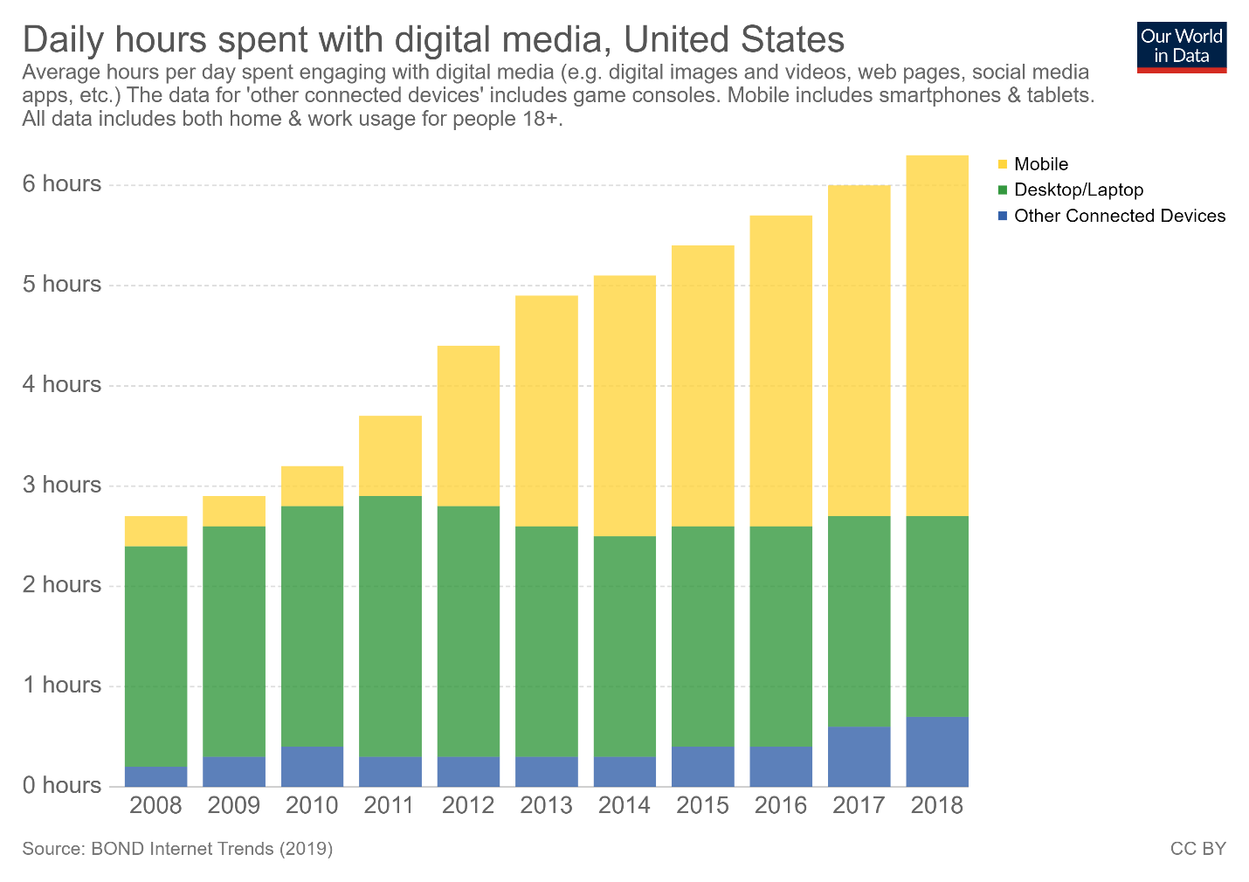

*Figure 1.* Bar graph of Daily hours spent with digital media, United States, 2015 Reprinted from *Internet*, Roser, M., Ritchie, H., & Ortiz-Ospina, E. 14 July 2015, retrieved from https://ourworldindata.org/internet.

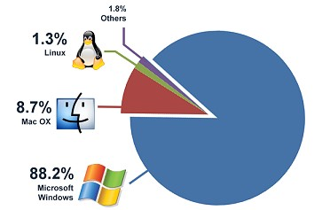

Figure 2. Pie chart of Operating system stats 2019. Reprinted from *My web stats: Browser and Operating System usage*, by Adam Dimech, 16th June 2011, retrieved from https://code.adonline.id.au/my-web-stats-browser-operating-system-usage/. Copyright © 2019 by Adam Dimech

## References:

## A (Plus) Certification: CompTIA IT Certifications. (n.d.). Retrieved October 20, 2019, from https://www.comptia.org/certifications/a.

## Are smartphones and tablets computers? (2018, November 13). Retrieved from https://www.computerhope.com/issues/ch001540.htm.

Bragg, S. (2018, March 24). SWOT analysis. Retrieved from https://www.accountingtools.com/articles/swot-analysis.html?rq=swot

Computer & Tablet Services. (n.d.). Retrieved October 20, 2019, from https://www.bestbuy.com/site/services/computer-tablet-services/pcmcat138100050019.c?id=pcmcat138100050019.

Dimech, A. (2011 June 16). My web stats: Browser and Operating System usage. Retrieved October 20, 2019, from https://code.adonline.id.au/my-web-stats-browser-operating-system-usage/.

Health Insurance Portability & Accountability Act. (2019). Retrieved October 20, 2019, from https://www.dhcs.ca.gov/formsandpubs/laws/hipaa/Pages/1.00WhatisHIPAA.aspx.

Kotler, P., & Keller, K. (2011). Marketing Management (14th ed.). Upper Saddle River: Prentice Hall.

Mustoe , L. (2019, June 4). What is PCI Compliance? Retrieved from https://digitalguardian.com/blog/what-pci-compliance.

Roser, M., Ritchie, H., & Ortiz-Ospina, E. (2015, July 14). Internet. Retrieved from https://ourworldindata.org/internet.

Tech Services. (n.d.). Retrieved October 20, 2019, from https://www.officedepot.com/cm/services/tech-services.

Tsirulnik, G. (2019). Mobile phone ranked most used electronic device: Forrester. Retrieved October 20, 2019, from https://www.mobilemarketer.com/ex/mobilemarketer/cms/news/research/7473.html.